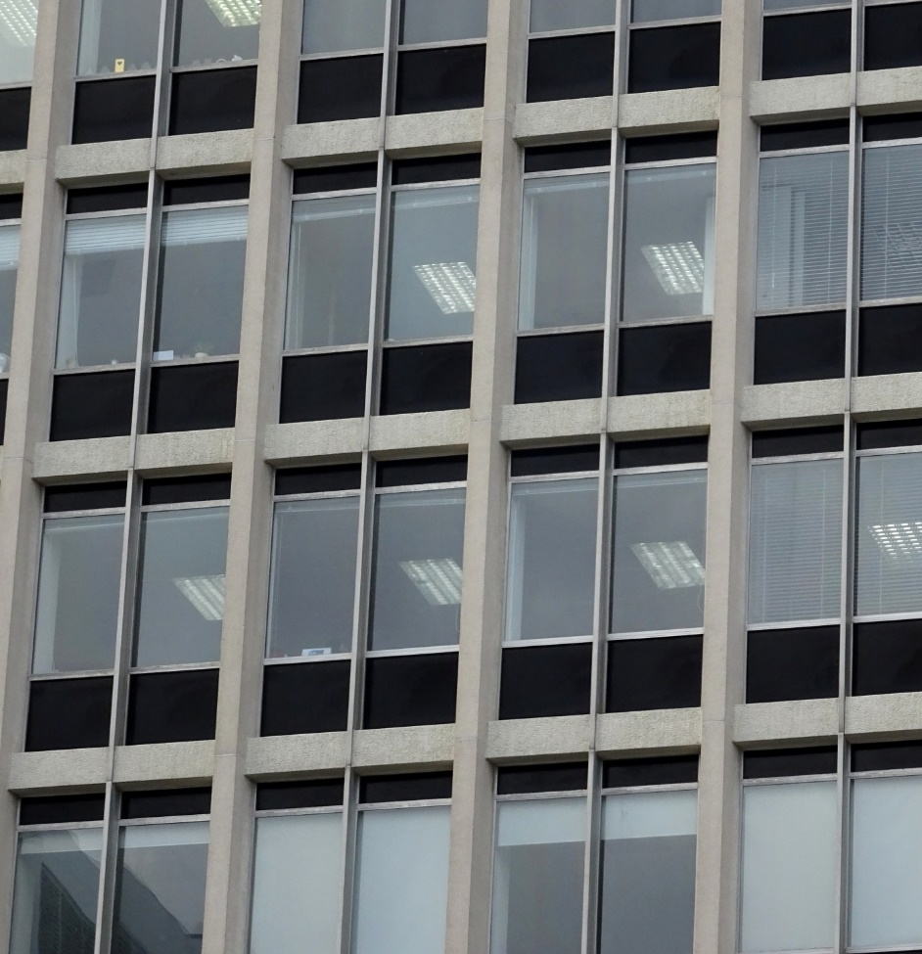
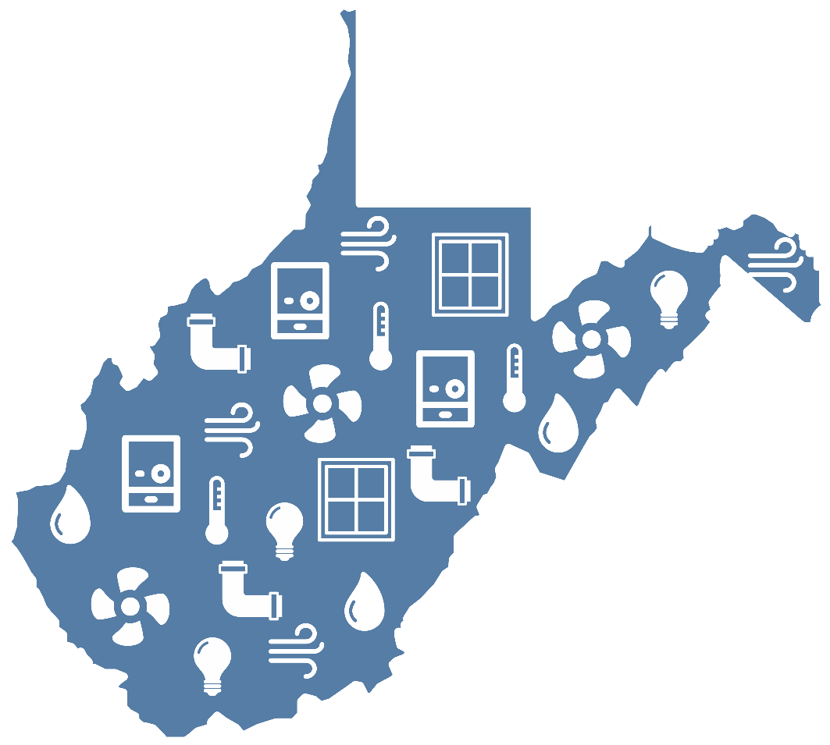
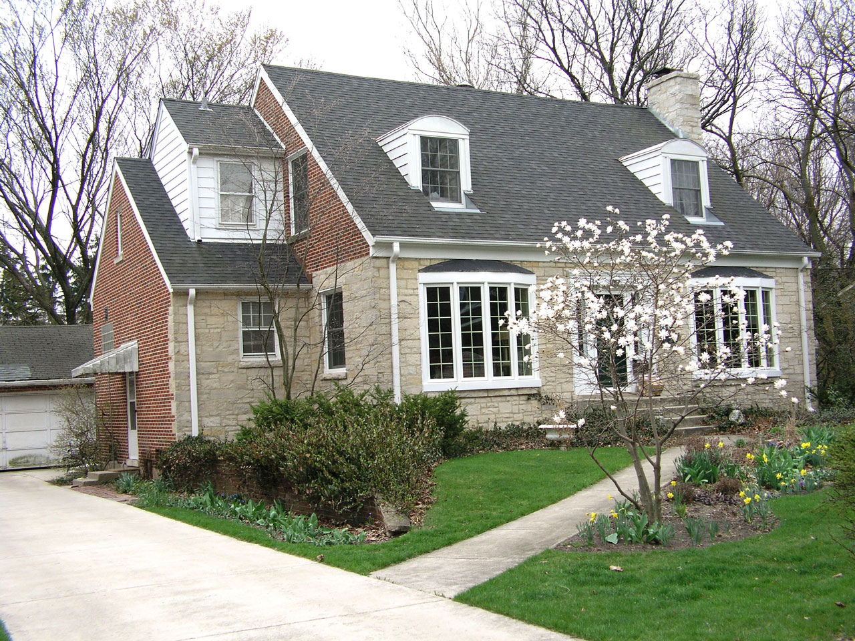

West Virginia Energy Code Primer

Prepared by:
Downstream Strategies

September 1, 2020
West Virginia Office of Energy
State Capitol Complex Building 3, Suite 600
Charleston, WV 25305-0311

(304) 558-2234
www.energywv.org

Table of Contents
Executive summary iv
1. Introduction 1
2. Benefits of adopting and enforcing energy codes 4
2.1 Economic enhancement 4
2.2 Job creation 6
2.3 Resilience 6
3. Energy efficiency in West Virginia buildings 8
4. West Virginia’s energy codes 11
4.1 Residential energy code 11
4.2 Commercial energy code 12
4.3 Energy code adoption 13
4.4 Energy code enforcement and compliance 13
5. Roadmap for cities and counties 15
References 18
Appendix A: Encouraging cities and counties to act 21
Appendix B: Energy code adoption by selected West Virginia jurisdictions 23

Table of Tables
Table 1: Municipalities and counties that adopted and enforce commercial energy codes 1
Table 2: Cost savings and payback periods for ASHRAE 2007, 2010, and 2013 5
Table 3: Cost savings for IECC 2009, 2012, and 2015 ($) 6
Table 4: Energy code adoption by selected West Virginia jurisdictions 16

Table of Figures
Figure 1: Systems and conditions regulated by energy codes 2
Figure 2: Built environment per capita energy consumption (million Btu) 8
Figure 3: National energy efficiency ranking and energy code scores 9
Figure 4: Estimated status of energy code adoption in residential buildings 10
Figure 5: Estimated status of energy code adoption in commercial buildings 10
Figure 6: Timeline of West Virginia’s energy code adoption 11
Figure 7: Climate zones by county 12

Abbreviations
ACEEE | American Council for an Energy-Efficient Economy
ASHRAE | American Society of Heating, Refrigerating, and Air-Conditioning Engineers
BCAP | Building Codes Assistance Project
ICC | International Code Council
IECC | International Energy Conservation Code
NEEP | Northeast Energy Efficiency Partnerships
USDOE | U.S. Department of Energy
Acknowledgements
This material is based on work funded by the U.S. Department of Energy’s Office of Energy Efficiency and Renewable Energy, State Energy Program Award Number DE-EE0007991. We thank Karen Lasure at the West Virginia Office of Energy; Emmett Pepper at Energy Efficient West Virginia; Kasey Osborne, Joey James, and Evan Hansen at Downstream Strategies; and Moses Riley at Northeast Energy Efficiency Partnerships for their feedback and assistance.
Partners
The West Virginia Office of Energy, housed within the West Virginia Development Office, formulates and implements fossil energy, renewable energy, and energy efficiency initiatives designed to advance energy resource development opportunities and provide energy services to businesses, communities, and homeowners in West Virginia.
Energy Efficient West Virginia is a group of concerned West Virginia residents, businesses, and community organizations that have come together to promote energy efficiency. It advocates for common-sense energy efficiency policy at the Public Service Commission, at the Legislature, and through work with local organizations and municipal governments.
DISCLAIMER
This report is prepared as an account of work sponsored by an agency of the United States Government. Neither the United States Government nor any agency thereof, nor any of their employees, makes any warranty, express or implied, or assumes any legal liability or responsibility for the accuracy, completeness, or usefulness of any information, apparatus, product, or process disclosed, or represents that its use would not infringe privately owned rights. Reference herein to any specific commercial product, process, or service by trade name, trademark, manufacturer, or otherwise does not necessarily constitute or imply its endorsement, recommendation, or favoring by the United States Government or any agency thereof. The views and opinions of authors expressed herein do not necessarily state or reflect those of the United States Government or any agency thereof.

Executive summary
West Virginia’s residential and commercial buildings—its “built environment”—are energy inefficient. Energy codes are simple and effective tools that cities and counties can use to make new buildings more efficient, thereby saving people and businesses money. This primer provides a roadmap that will help local leaders across the state adopt and enforce energy codes to improve the efficiency of new and renovated buildings.
Across West Virginia, very few municipalities and counties have adopted energy codes. Only eight municipalities and two counties are known to be enforcing commercial energy codes. The number of jurisdictions enforcing residential energy codes is not known. Local jurisdictions are not seizing many easy opportunities to save money and reduce emissions.
When West Virginia adopts an energy code at the state level, local jurisdictions are not required to adopt it. In jurisdictions that do not adopt the code, the state-adopted code is in force, but enforcement is basically carried out through the honor system. This lack of regulation means compliance is likely spotty or even nonexistent in some areas.
Energy codes cover components of the building itself, such as wall insulation, windows, and air and duct leakage (see Figure ES-1); regulating these elements determines the thermal envelope of a building, thereby controlling moisture, air exchange, and thermal properties. These features not only translate to energy and cost savings over the life of the building, but also appreciate property value, increase comfort for occupants, improve building durability, improve health, and maintain safety.
Figure ES-1: Systems and conditions regulated by energy codes
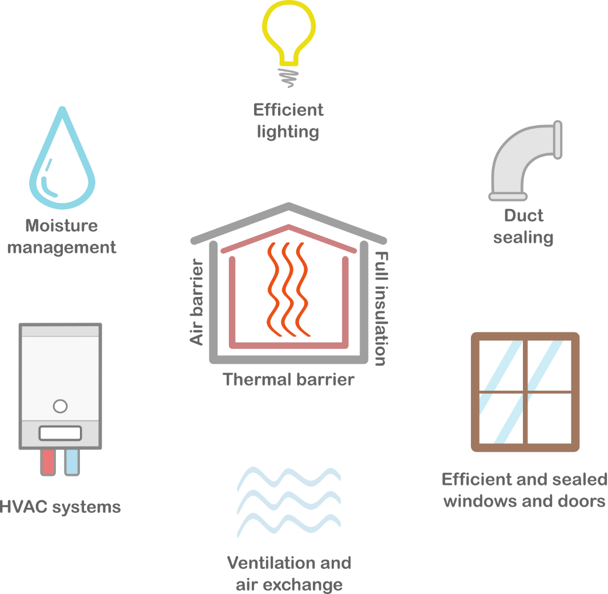
Benefits of adopting and enforcing energy codes
Energy codes have many concrete benefits. Consumers and homebuyers can enjoy clean indoor air, lower utility bills, and sustainable homes. Businesses can reduce overhead spending, expand investment opportunities, and gain energy independence.
Economic enhancement: Buildings that comply with updated energy codes are simply more cost-effective to operate, yielding compounding savings over time for consumers. This means returning money to homeowners’ and businessowners’ pockets to be redistributed back into the local economy, investments, business improvements, and other goods and services.
Job creation: Enforcing energy codes also creates opportunities for energy, building technology, and construction-related industries. As energy codes become increasingly efficient and widespread, the demand for and diversity of jobs will also increase. Jobs range from trade to professional positions and include technical experts, leakage specialists, quality control assessors, code officials, commissioning agents, energy auditors, designers, construction workers, and compliance officers.
Resilience: Energy codes also guard against preventable environmental conditions related to moisture, air quality, fire, and extreme weather events that can diminish human—and building—health. Energy codes help prevent the formation of rot, mold, and mildew by controlling moisture from condensation, which develops when warm air meets a cold surface. Because energy codes prevent unsafe conditions in indoor air and reduce emissions that decrease outdoor air quality, they play a direct role in protecting human health.
Energy efficiency in West Virginia buildings
West Virginia has the highest residential electricity consumption per household east of the Mississippi River and the highest total energy consumption per capita in the Appalachian region (see Figure ES-2).
West Virginia tied with Mississippi as the 48th-least energy efficiency–friendly state in the nation, topping only North Dakota and Wyoming (see Figure ES-3).
Figure ES-2: Built environment per capita energy consumption (million Btu)
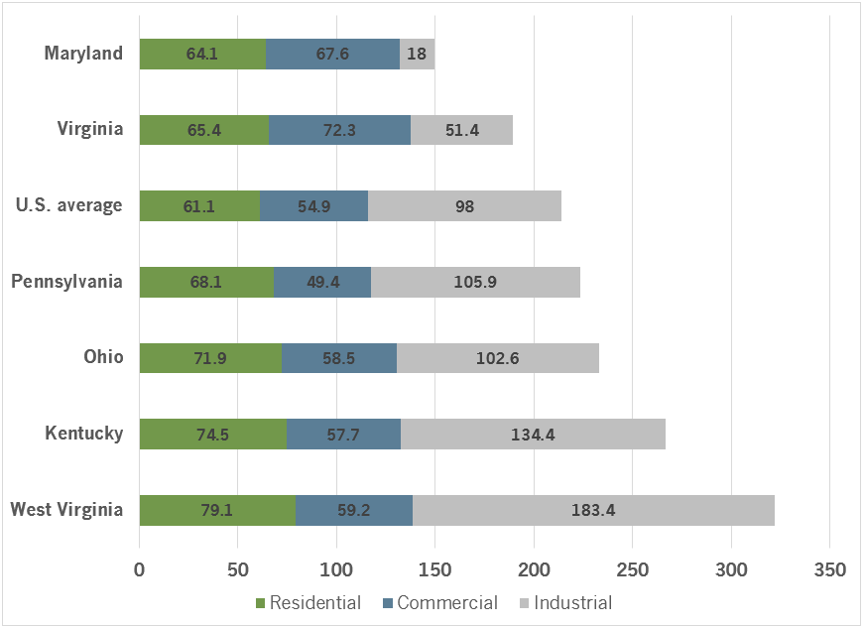
Figure ES-3: National energy efficiency ranking and energy code scores
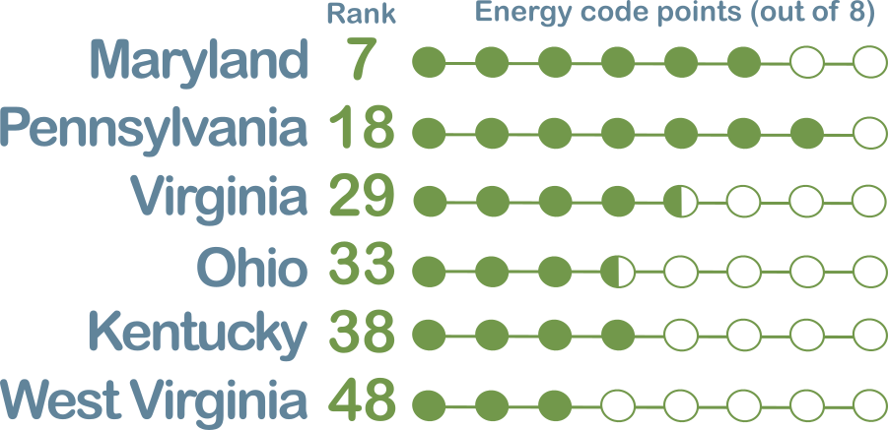

West Virginia’s energy codes
West Virginia has adopted the IECC 2009 energy code for residential buildings and the ASHRAE 90.1-2010 energy code for commercial buildings (see Figure ES-4,).
Figure ES-4: Timeline of West Virginia’s energy code adoption
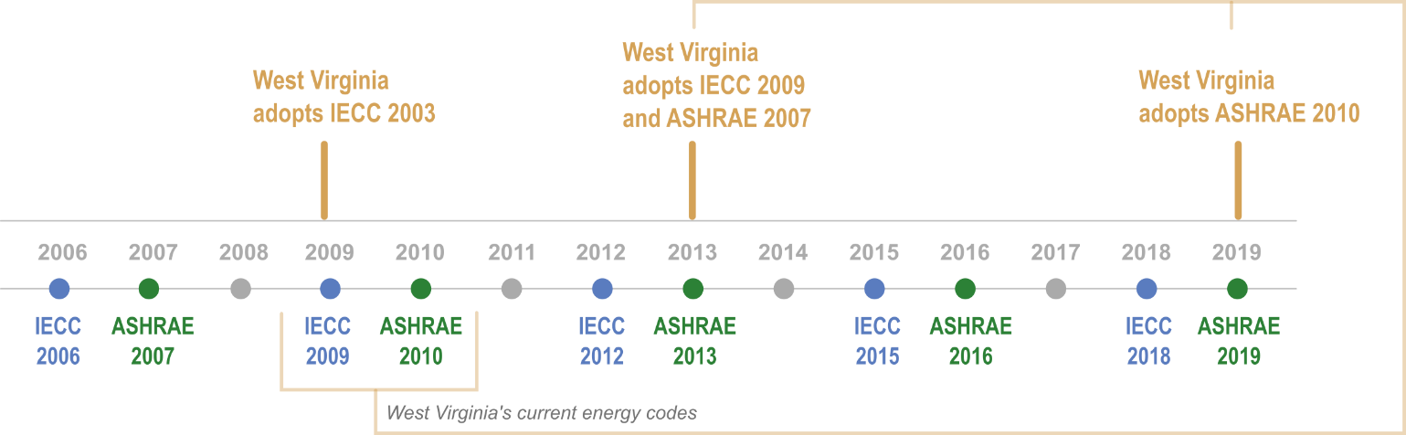

Energy codes are only effective when they are adopted and enforced. After an energy code is adopted at the state level, local jurisdictions may take action to adopt and enforce the state code. Additionally, while the state code outlines the minimum requirements, a local jurisdiction can voluntarily go beyond the base code in the form of an enhancing or “stretch” code, which is more aggressive and will yield greater energy savings.
Ultimately, a variety of individuals and entities play a role in achieving high levels of compliance—not just the diligence of building officials. Professions involved include architects, designers, contractors and construction professionals, real estate professionals, home inspectors, carpenters, brick masons, masons, concrete finishers, roofers, electricians, engineers, insulation workers, and energy modelers.
The most widely used energy code compliance tools are two software programs: COMcheck for commercial buildings and REScheck for residential buildings. These programs certify whether a building meets the requirements of the selected code, based on variables that are entered. At no cost, these programs can help inform design decisions, as well as serve as legal protection. Building officials and inspectors also use them to simply and efficiently determine whether a building meets the code.
Roadmap for cities and counties
While the cost savings figures at the end of long-term projections are impressive, they are only attainable with consistent and widespread adoption, enforcement, and compliance with updated codes. Statewide compliance, however, starts at the community level. Ultimately, it is the local jurisdictions that adopt—and more importantly, enforce—energy codes that will help businesses and residents fully realize the codes’ energy and cost savings.
The following roadmap will help local governments get incrementally closer to this goal with each milestone. While each phase will entail a series of sub-steps, which will vary depending on the needs and status of a certain jurisdiction, they can all be organized into three primary actions: (1) Engage stakeholders, (2) Adopt residential and commercial energy codes through an ordinance, and (3) Enforce the adopted residential and commercial energy codes.
Engage stakeholders
- Form a diverse working group of affected individuals
- Establish objective and realistic goals
Adopt residential and commercial energy codes
3
1
- From the working group, decide energy efficiency goals to pursue
- Adopt the energy code through an ordinance
Enforce the adopted energy codes
2
- Train code officials in energy-related building science
- Code officials ensure compliance tasks are completed
- Create and distribute education and training resources to officials, industry, and consumers

Introduction
West Virginia’s residential and commercial buildings—its “built environment”—are energy inefficient. Energy codes are simple and effective tools that cities and counties can use to make new buildings more efficient, thereby saving people and businesses money. This primer provides a roadmap (See Chapter 5) that will help local leaders across the state adopt and enforce energy codes to improve the efficiency of new and renovated buildings.
Across West Virginia, very few municipalities and counties have adopted energy codes. As shown in Table 1, only eight municipalities and two counties are known to be enforcing commercial energy codes. The number of jurisdictions enforcing residential energy codes is not known. Local jurisdictions are not seizing many easy opportunities to save money and reduce emissions.
Table 1: Municipalities and counties that adopted and enforce commercial energy codes
Jurisdiction | Version adopted
Municipalities
Barboursville | Not known
Charleston | 2007
Granville | 2013
Martinsburg | 2007
Morgantown | 2010
Moundsville | 2013
Summersville | 2007
Wheeling | 2007
Counties
Berkeley County | 2007
Jefferson County | 2007
Source: Lasure (2020).
Energy codes, the focus of this primer, are among the most recent types of building codes. Building codes, more generally, are a collection of statutory requirements that regulate various aspects of the physical construction, conditions, and performance of new or proposed buildings and building sites. The first uniform national code was the 1905 National Building Code (McNabb, 2013).
Simply adopting an energy code is not enough to enjoy their benefits. When West Virginia adopts an energy code at the state level, local jurisdictions are not required to adopt it. Many jurisdictions neither adopt nor enforce any energy code at all. In jurisdictions that do not adopt the code, the state-adopted code is in force, but enforcement is basically carried out through the honor system. With no local enforcing authority, designers and builders must take it upon themselves to ensure building plans are to code. This lack of regulation means compliance is likely spotty or even nonexistent in some areas.
Now, building codes—which can refer to the overall “building code” for a jurisdiction or a subtype of the code, such as structural, plumbing, electrical, and energy codes—establish a consistent standard and minimum legal requirements for the design of buildings, materials used, construction practices, protection against fire and flooding, and other structural features. These minimum requirements not only protect and improve the health, safety, and general welfare of occupants and the public, but also safeguard investments, enhance building stock, reduce insurance rates, conserve energy, and save money. (Federal Emergency Management Agency, 2014)
Figure 1: Systems and conditions regulated by energy codes
Energy codes work to align buildings with sustainability and cost management goals by establishing minimum energy efficiency requirements. As detailed in Chapter 2, energy codes are increasingly recognized for their importance to human health and safety, public benefit, cost and energy savings, and building durability (Cohan, 2016c). Enforcing energy codes achieves significant savings in energy and costs at the building, state, and national levels. Between 2012 and 2040, energy codes are projected to save U.S. homes and businesses $126 billion and 12.82 quads of primary energy (Mendon et al., 2015; DOE, 2017).
For West Virginia, between 2018 and 2022, enforcing the currently adopted residential energy code can net nearly $11 million in cost savings, which is the same as:
- funding 272 students to attend a four-year college,
- building 83 miles of new bike lanes, or
- powering 14,226 homes for one year (NEEP, 2018).

The first energy codes were adopted in the late 1970s and have been updated frequently since then. These codes generally apply to newly constructed or proposed buildings, additions, renovations, and retrofits. Energy codes cover components of the building itself, such as wall insulation, windows, and air and duct leakage (see Figure 1); regulating these elements determines the thermal envelope of a building, thereby controlling moisture, air exchange, and thermal properties. (USDOE, 2016)
These features not only translate to energy and cost savings over the life of the building, but also appreciate property value, increase comfort for occupants, improve building durability, improve health, and maintain safety. Because of this, residents should have the “right to buildings that meet national standards for energy efficiency” (BCAP, 2012, p.1) and are constructed with “the occupant’s best interests in mind, which carry over to all facets of construction.” (Weeks, 2014)
Two organizations preside over energy codes: The International Code Council (ICC) and the American Society of Heating, Refrigerating, and Air-Conditioning Engineers (ASHRAE). These organizations independently create the two baseline codes used in the United States: The ICC publishes the International Energy Conservation Code (IECC), and ASHRAE publishes the ANSI/ASHRAE/IESNA Standard 90.1. (Cohan, 2016a)
The IECC is the model energy code for residential construction and includes chapters for commercial buildings, but it allows ASHRAE 90.1 to substitute for commercial structures, which is the model energy code for commercial buildings.
Building codes constantly evolve to account for technological advancements, new insights into the effects of energy consumption, policy changes, and the landscape of construction standards. While building codes only define “the floor” or bare minimum, constructing to and beyond existing energy codes will ensure that buildings meet future requirements and building owners reap benefits in the long term. Because buildings use 40 percent of the nation’s energy and 70 percent of its electricity, “reducing energy use in the built environment through the adoption and enforcement of energy codes is one of the quickest, cheapest, and cleanest ways to help ensure a sustainable and prosperous future” (BCAP, 2014, p. 1; Livingston et al., 2014).
Chapter 2 outlines many of the consumer and economic benefits that energy code compliance can bring. Chapter 3 discusses how West Virginia’s energy efficiency and energy codes compare to those of neighboring states. Chapter 4 provides a brief background on how energy codes came to be, which energy codes West Virginia has adopted, and the basic procedure for energy code adoption, enforcement, and compliance in the state. Chapter 5 provides a roadmap for local government officials that wish to adopt or strengthen their energy codes.

Benefits of adopting and enforcing energy codes
Despite energy codes’ late arrival relative to many other long-standing building codes, they have had many concrete benefits: consumers and homebuyers can enjoy clean indoor air, lower utility bills, and sustainable homes, and businesses can reduce overhead spending, expand investment opportunities, and gain energy independence. Considering that residential and commercial buildings consume 40 percent of the nation’s energy—and that energy codes regulate as much as 80 percent of a building’s energy load—adopting and enforcing energy codes can reduce total national energy demand by one-third. (USDOE, 2015)

Economic enhancement
Buildings that comply with updated energy codes are simply more cost-effective to operate, yielding compounding savings over time for consumers. This means returning money to homeowners’ and businessowners’ pockets to be redistributed back into the local economy, investments, business improvements, and other goods and services. Energy codes give agency to consumers when buying, renting, or leasing a building by setting a base standard and preventing disproportionately high utility bills and costly retrofits. Occupants not only enjoy cost savings but are protected against the unforeseen and potentially drastic negative economic consequences of energy inefficiency; buildings that fail to meet energy code requirements can plague occupants with debilitating utility bills and subsequent financial hardship.
USDOE estimated that U.S. home and business owners could shave $126 billion off their utility bills by 2040, even when considering just modest energy code updates and patchy enforcement (Athalye et al., 2016; NEEP, 2018). U.S. consumers have saved $44 billion thanks to the adoption of energy codes over the past several decades (U.S. Environmental Protection Agency, 2015). However, as technologies improve, these numbers will likely grow; energy codes today already yield 30 percent more energy savings than they did 10 years ago (Athalye et al., 2016).
For West Virginia:
- Home and business owners could save up to $50 million annually by adopting more stringent energy codes by 2030 (USDOE, 2013).
- Individuals can save $2,259–$2,466 over a 30-year period of home ownership by adopting the 2009 IECC over the 2006 version (Mendon et al., 2013).
- Those savings can triple to $7,625–$9,189 by adhering to the more stringent but not-yet-adopted 2012 IECC. (USDOE, 2012).
Table 2 compares the cost savings and payback periods for updated energy code standards for commercial buildings in climate zones 4A and 5A, the two zones in West Virginia. Table 3 presents similar information for residential buildings.
Because energy codes have such a significant hand in maintaining a healthy indoor living environment, abiding by them would save $20 billion in avoided health care costs (NEEP, 2018).

Table 2: Cost savings and payback periods for ASHRAE 2007, 2010, and 2013
 | Climate zone 4A |  |  |  | Climate zone 5A
Building type | Annual energy cost savings ($) | Life cycle energy cost savings ($) | Simple payback period (years) |  | Annual energy cost savings ($) | Life cycle energy cost savings ($) | Simple payback period (years)
ASHRAE 2010 versus 2007
Small office | 973 | 6,100 | 15.5 |  | 993 | 14,300 | 8.7
Large office | 124,939 | 1,500,000 | 4.1 |  | 110,379 | 1,730,000 | 2.2
Standalone retail | 8,671 | 74,000 | 8.8 |  | 9,176 | 121,000 | 5.7
Primary school | 24,580 | 197,000 | 6.7 |  | 24,810 | 307,000 | 4.5
Small hotel | 5,209 | 284,700 | 1.4 |  | 5,320 | 325,000 | Immediate
Mid-rise apartment | 2,069 | 30,800 | 10.1 |  | 2,593 | 41,800 | 8
ASHRAE 2013 versus 2010
Small office | 567 | 2,900 | 22 |  | 535 | 5,000 | 17
Large office | 17,461 | 300,000 | 5.1 |  | 14,079 | 1,340,000 | Immediate
Standalone retail | 4,551 | 67,000 | Immediate |  | 5,116 | 79,000 | Immediate
Primary school | 11,705 | 70,000 | 14.3 |  | 11,520 | 54,000 | 15.6
Small hotel | 4,588 | 62,000 | 7.2 |  | 4,602 | 57,000 | 8.7
Mid-rise apartment | 1,868 | 29,200 | 7.2 |  | 2,083 | 28,500 | 9.7
Sources: Thornton et al. (2013) and Hart et al. (2015).

Table 3: Cost savings for IECC 2009, 2012, and 2015 ($)
 | 2009 | 2012 | 2015
First-year energy costs | 1,427 | 1,769 | 1,068
Annual energy cost savings (over 2006) | 134 | 476 | 500
Annual energy cost savings (over 2009) | -- | 342 | 360
Life cycle cost savings (over 2006) | 1,957 | 7,239 | 7,301
Life cycle cost savings (over 2009) | -- | 5,260 | 4,552
Sources: All cost savings are from Menden et al. (2013, 2015, 2016), except the 2015 annual energy cost savings (over 2006), which is from USDOE (2016).

Job creation
Enforcing energy codes also creates opportunities for energy, building technology, and construction-related industries. As energy codes become increasingly efficient and widespread, the demand for and diversity of jobs will also increase. Jobs range from trade to professional positions and include technical experts, leakage specialists, quality control assessors, code officials, commissioning agents, energy auditors, designers, construction workers, and compliance officers. (USDOE, 2011).
Construction jobs generated from energy efficiency initiatives are especially positioned to benefit from energy code compliance. In 2019 alone, 54,000 net jobs in energy efficiency were added nationally, a 3.4 percent increase from the previous year. The energy efficiency workforce includes approximately 2.4 million employees—1.3 million of whom are in construction. Because energy codes inherently depend on the construction industry, construction jobs represent the majority of job opportunities in energy efficiency. In 2019, 27,600 energy efficiency jobs were added nationally; of these construction employees, 78 percent reported that most of their time was committed exclusively to energy efficiency work. (National Association of State Energy Officials and Energy Futures Initiative, 2020)
West Virginia’s 7,144 jobs in energy efficiency can be increased dramatically from energy code compliance. In 2020, these jobs represented just 13 percent of all jobs in the state’s traditional energy sector; for comparison, energy efficiency jobs represented 35 percent of traditional energy sector jobs across the country. (National Association of State Energy Officials and Energy Futures Initiative, 2020)
Many communities are investing in workforce development activities and incentives to help bolster and expand energy efficiency jobs. As shown in the overview of neighboring states in Chapter 3, Maryland boasts the highest marks for energy efficiency, which is likely helped by its EmPOWER initiative, which is estimated to create 68,000 new net jobs, increase state gross domestic product by $3.75 billion, and save $12 billion for homes and businesses (ACEEE, 2017).

Resilience

Health, safety, and building durability
Energy codes yield cost and energy savings and guard against preventable environmental conditions related to moisture, air quality, fire, and extreme weather events that can diminish human—and building—health. Energy codes work to safeguard the occupant as well as the investment (Spinu, 2012). Because of this, energy codes “go beyond energy and cost savings—energy codes are life safety codes” (NEEP, 2018).
The main objective of an energy code is a tight thermal envelope, also called a building envelope; it is a barrier that separates conditioned space from unconditioned space, such as floors, insulation, ceilings, floors, walls, and windows. A tight thermal envelope prevents the exchange of conditioned and unconditioned air, which can have far-reaching effects, as described below (Meres and Makela, 2013).

Moisture
Energy codes help prevent the formation of rot, mold, and mildew by controlling moisture from condensation, which develops when warm air meets a cold surface. Rot compromises the structural integrity of a building, which degrades the building’s durability and makes it dangerous to occupy. Mold and mildew can cause serious health complications, ranging from respiratory reactions to neurologic damage—sometimes even death. Some energy code measures that help prevent moisture issues include:
- Air barriers are created when any openings that would permit unwanted airflow are sealed. Because air carries moisture, moisture is less likely to invade the wall cavities.
- Insulated and sealed ceilings prevent ice dams from forming and allowing water to leak into the house.
- Efficient, well-insulated, and well-sealed windows prevent unwanted heat transfer and reduce condensation that would damage nearby building materials.
- Appropriately sized heating, ventilation and air conditioning systems with sealed ductwork have longer service lives and dehumidify the air effectively. (Meres, 2015; Brinker, 2018)

Air quality
Per the saying, “Build tight and ventilate right,” proper ventilation and air sealing are critical to the thermal envelope and healthy air quality. If unwanted air exchange, drafts, and leaks occur, pollutants and contaminants from outside, such as exhaust or lawn chemicals, can seep into living space. Highly regulated air exchange and air sealing prevent the spread of contaminants and improve whole-house ventilation; efficient ventilation also prevents pollutants from within the house, such as those from cleaners and paints, from lingering in the living space instead of aerating outside. Poor air sealing in supply and return duct systems increase the risk of backdrafting in combustion appliances, which can be particularly dangerous. (Brinker, 2018; Meres, 2015)
Because energy codes prevent unsafe conditions in indoor air and reduce emissions that decrease outdoor air quality, they play a direct role in protecting human health. Reducing energy consumption nationwide by 15 percent annually would save six lives daily and prevent 30,000 asthma episodes (NEEP, 2019; USDOE, 2015). Energy codes can also help mitigate the effects of fires. Because of the highly regulated air exchange, the spread of fire and smoke throughout the structure—or from one building to another—is slowed (Brinker, 2018).

Extreme weather
Extreme weather—heat waves, cold snaps, flooding, and more—can quickly make buildings unsafe due to dangerous temperature and moisture levels, especially when there is a power outage or other system loss (USDOE, 2016). An energy-efficient building keeps the indoor temperature warmer longer when it is cold out, and cooler longer when it is hot out: This keeps the building stable, safe, and “passively survivable,” which allows occupants to remain inside for longer periods of time during power loss and when sheltering in place. (NEEP, 2019; Brinker, 2018; Meres, 2015) The thermal envelope still functions even when other major building systems are down (Brinker, 2018).

Energy efficiency in West Virginia buildings
While West Virginia is a net exporter of electricity and a national leader in interstate electricity sales, West Virginians pay disproportionately high electricity bills. This, in large part, is due to the inefficiency of the state’s built environment. West Virginia has the highest residential electricity consumption per household east of the Mississippi River and the highest total energy consumption per capita in the Appalachian region (see Figure 2) (U.S. Energy Information Administration, 2020).
Figure 2: Built environment per capita energy consumption (million Btu)
Source: U.S. Energy Information Administration (2020).
West Virginia tied with Mississippi as the 48th-least energy efficiency–friendly state in the nation, topping only North Dakota and Wyoming (see Figure 3). This ranking is based on a cumulative score that includes energy codes and five other categories: utilities, transportation, combined heat and power, state initiatives, and appliance standards. As illustrated in Figure 3, West Virginia trails behind each bordering state in both its overall energy efficiency rank and its energy code score.
Figure 3: National energy efficiency ranking and energy code scores
Source: Adapted from ACEEE (2019).
ACEEE’s findings are also consistent with those of the U.S. Department of Energy (USDOE). USDOE tracks the adoption of residential and commercial energy codes throughout the country by conducting a quantitative analysis of energy savings impacts within a given state using USDOE’s simulation program and a number of state-specific factors. The analysis results in an energy index and underlying energy use intensity values, which are then used to categorize each state according to recent model codes. (USDOE, 2019b)
For residential buildings, the only neighboring state to show energy savings that go beyond 2009 IECC was Maryland. Maryland leads in residential energy efficiency in the region and much of the eastern part of the country by adopting the latest 2018 building code at the state level, and USDOE validates the IECC 2018 savings (See Figure 4). (USDOE, 2019b)
For commercial buildings, West Virginia’s 2010 standard surpasses both Ohio and Kentucky, which are classified as having adopted the 2007 standard (See Figure 5). Among neighboring states, Pennsylvania, Virginia, and Maryland are the frontrunners, with energy efficiency equivalent to the 2013 standard. (USDOE, 2019b)
West Virginia lags many states in energy code adoption. Further, no matter which energy code the state adopts, it can easily be rendered meaningless because adoption and enforcement are only effectively enacted at the local jurisdictional level—and on a voluntary schedule, at that. A local jurisdiction may even adopt an energy code but stop short of enforcing it, or simply not adopt any energy code at all. However, because West Virginia’s existing energy codes are at the lower end of an improving lineup of new editions, municipalities have significant opportunities to meet—and even exceed—standards.

Figure 4: Estimated status of energy code adoption in residential buildings
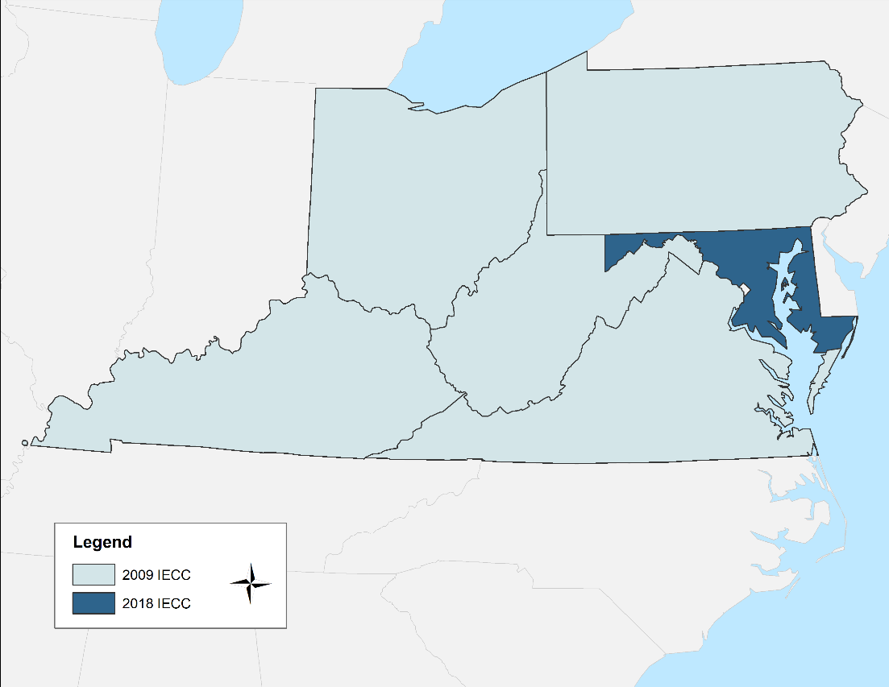
Source: Adapted from USDOE (2019a).
Figure 5: Estimated status of energy code adoption in commercial buildings
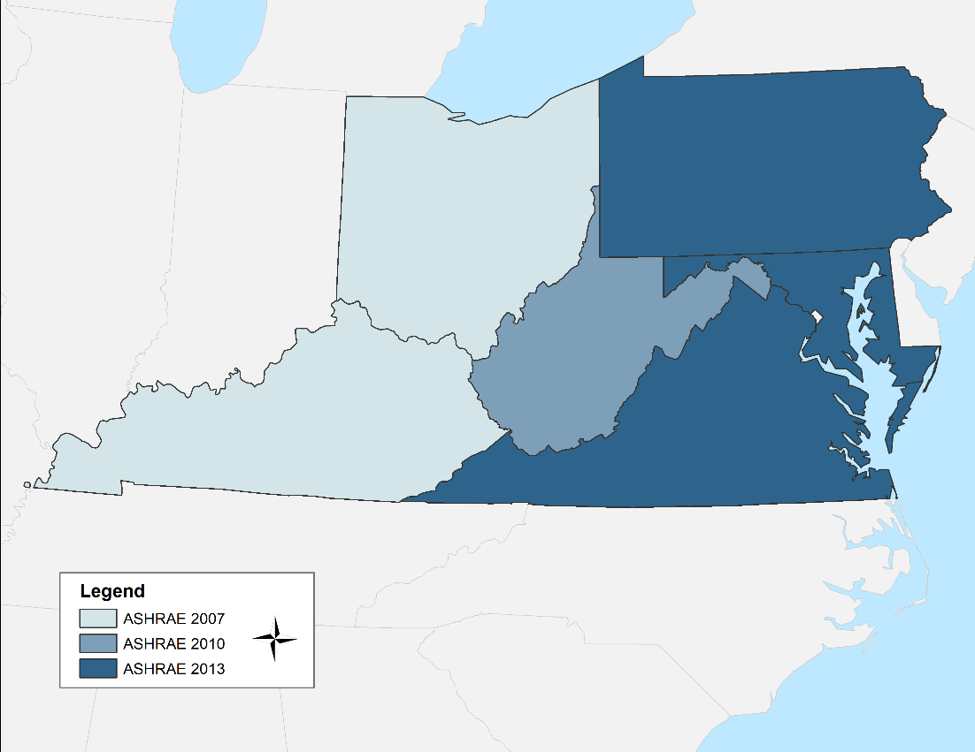
Source: Adapted from USDOE (2019a).

West Virginia’s energy codes
As illustrated in Figure 6, West Virginia has adopted the IECC 2009 energy code for residential buildings and the ASHRAE 90.1-2010 energy code for commercial buildings.
Some code requirements, such as insulation, window, and door details, vary with climate zone designation. Both the ASHRAE and IECC codes work from the same climate map. West Virginia falls within the climate zones and moisture regime 5A (cool, humid) and 4A (mixed, humid) (see Figure 7). (Heinking and Zussman, 2019)
Figure 6: Timeline of West Virginia’s energy code adoption

Residential energy code
In 2013, West Virginia adopted the 2009 IECC for residential buildings, replacing the 2003 IECC. The main differences between these codes include improvements to the thermal envelope.
The residential portion of the IECC applies to new construction, additions, alterations, renovations, and repairs on:
- houses with three or fewer stories (including single-family, multi-family, and townhouses),
- condominiums, and
- apartments.
It does not apply to:
- buildings with very low energy use,
- entire buildings or portions of buildings that are not heated or cooled,
- existing buildings or unaltered areas during renovations (electrical power, lighting, and mechanical systems still apply; see Section 101.4.1), or
- buildings designated as historic.
In the case of mixed-use buildings in which one area is commercial and one is residential—such as a residential apartment above a commercial restaurant—the residential code is applicable to the residential section, and the commercial code is applicable to the commercial section. The entire building does not need to conform to a single code.

Figure 7: Climate zones by county
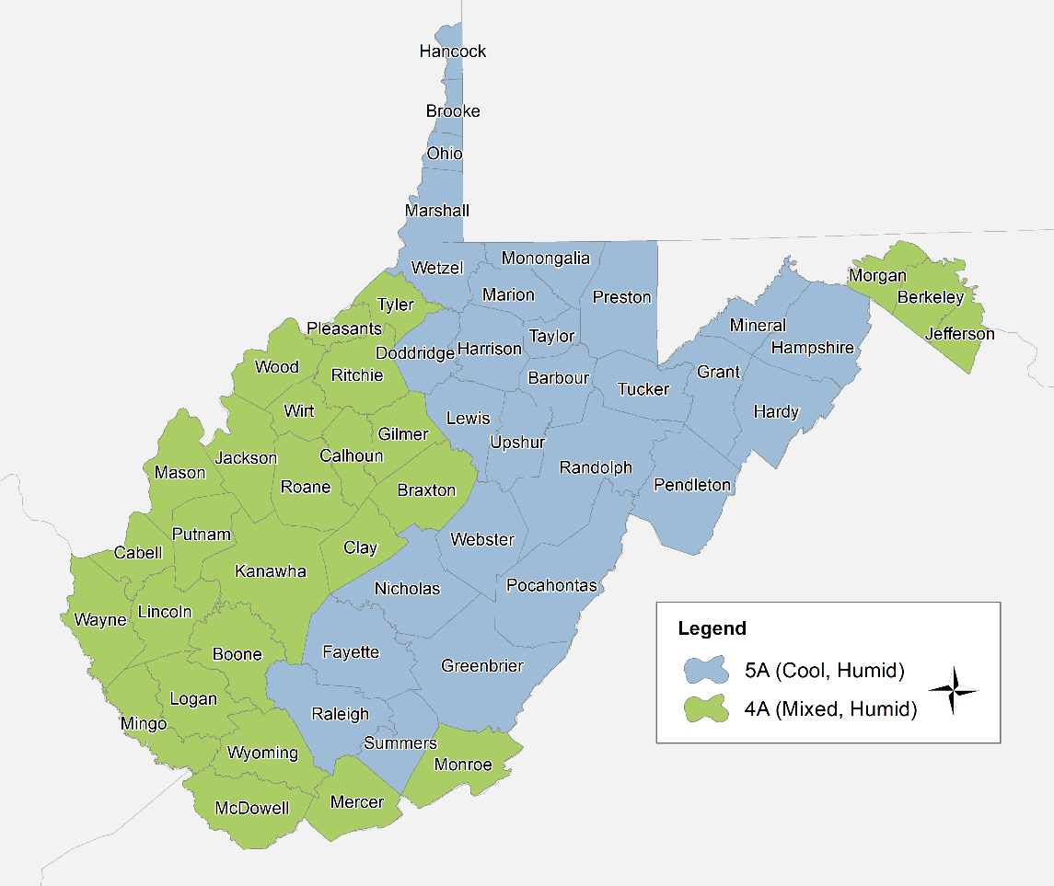

Commercial energy code
In 2019, West Virginia adopted ASHRAE Standard 90.1-2010. This updated the state’s commercial energy code from the 2007 version.
ASHRAE 90.1 applies to all commercial buildings or commercial segments of buildings. More specifically, it applies to new construction, additions, alterations, renovations, and repairs on:
- high rise (four or more stories) residential (e.g., dormitories, nursing homes, hospital patients’ rooms, prisons, hostels) buildings,
- previously exempt equipment or building systems specifically identified that are part of the industrial or manufacturing process, and
- commercial buildings or commercial segments of mixed-use buildings.
It does not apply to:
- residential buildings with three or fewer stories,
- buildings without electricity or fossil fuel use,
- entire buildings or portions of buildings that are not heated or cooled,
- spaces with a design load of 15,000 Btu per hour for cooling,
- existing buildings or unaltered areas during renovation, or
- buildings designated as historic.

Energy code adoption
States adopt energy codes, but their adoption is triggered by a positive determination from USDOE. If USDOE determines that a new version of a code would yield significant energy and cost savings, then the federal government requires that states review and potentially update their current energy code should the state deem it necessary. In West Virginia, if the code is adopted at the state level, the State Fire Commission then announces new requirements to local jurisdictions. Local jurisdictions may then take action to adopt or not adopt these new requirements. (USDOE, 2020a)
In West Virginia, energy codes are adopted via the state’s standard rulemaking process:
- First, the State Fire Commission proposes that an energy code be adopted. This process includes public hearings.
- The Commission then files a rule adopting the new energy code with the Secretary of State.
- The Commission conducts a public hearing and can then modify the rule.
- The rule is then filed with the Legislative Rule-Making Review Committee for approval or modification.
- The rule is then introduced as a bill during the legislative session. The Legislature can alter it during the session. Once it passes, the governor can sign it into law, veto it, or allow it to become law without his or her signature.
- The Commission then spreads awareness of the new code to local jurisdictions, which may voluntarily adopt the code directly, a strengthening code, or a portion of a strengthening code.
Because both the ASHRAE and IECC codes are updated on a three-year schedule, keeping up to the latest code can be infeasible and sometimes not even cost-effective for many regions. For example, complying with the 2009 over the 2006 IECC would reduce energy use by 14 percent and complying with the 2012 IECC over the 2009 IECC would save an additional 21 percent. However, moving from the 2012 to the 2015 code would only save an additional 1 percent.
As illustrated above in Figure 6, the most recent energy code editions are 2018 for IECC and 2019 for ASHRAE. While some states are required to adopt each new energy code within a certain time period of its publication or observe a regular review schedule (often three years, to reflect the two main codes’ revision cycles) West Virginia does not currently follow an established process for reviewing and adopting new energy codes proactively. (NEEP, 2018)

Energy code enforcement and compliance
Energy codes are only effective when they are adopted and enforced. After an energy code is adopted at the state level, local jurisdictions may take action to adopt and enforce the state code. Additionally, while the state code outlines the minimum requirements, a local jurisdiction can voluntarily go beyond the base code in the form of an enhancing or “stretch” code, which is more aggressive and will yield greater energy savings.
- If a local jurisdiction chooses to adopt the statewide codes (or another, enhancing code), the jurisdiction becomes the enforcing authority, and local building officials ensure compliance through plan reviews and inspections.
- For local jurisdictions that do not adopt the statewide codes, the State Fire Marshal is responsible for enforcement. In these areas, enforcement is generally accomplished through the honor system in which contractors, builders, and architects ensure their designs abide by the code requirements.
Compliance can fall under the responsibility of different players depending on local ordinances, and while designers and builders must legally meet the code requirements, subcontractors and workers are integral in ensuring compliance. Legal issues can arise when an enforcement authority is not present or prepared to ensure a building certified as built to code is actually meeting those code requirements (USDOE, 2019; ACEEE, 2019)
For locales that have adopted an energy code, the building owner and relevant individuals follow the basic steps below to achieve enforcement:
- Generally, codes are enforced by obtaining a permit from the local government’s building department.
- Applicants must produce detailed plans and specifications that are reviewed and, if requirements are met, approved.
- Then, inspections and tests are conducted at different points during construction: For example, wall insulation is checked before drywall is installed.
Ultimately, a variety of individuals and entities play a role in achieving high levels of compliance—not just the diligence of building officials. (Cohan, 2016c) Professions involved include architects, designers, contractors and construction professionals, real estate professionals, home inspectors, carpenters, brick masons, masons, concrete finishers, roofers, electricians, engineers, insulation workers, and energy modelers. (Missouri Department of Natural Resources, 2012)

Compliance pathways
Energy codes allow for some flexibility in how compliance can be achieved by providing pathways beyond simply checking off each requirement listed in the code. Builders and designers can take advantage of alternative pathways that still achieve energy code compliance but allow innovative approaches and techniques that would otherwise not be possible.
Generally, these pathways include mandatory, prescriptive, or tradeoff requirements, as discussed below. Each energy code might have different pathways for compliance.
- Some mandatory requirements must be met regardless of the compliance pathway chosen.
- Prescriptive: This pathway is the most straightforward. Every part of the building design must adhere to the energy code.
- Envelope tradeoff: This pathway allows one part of the building envelope to not meet requirements if another part of the design “makes up” for not meeting the requirement.

Compliance tools
The most widely used energy code compliance tools are two software programs: COMcheck for commercial buildings and REScheck for residential buildings. Building specifications, energy code, compliance pathway, and other variables are entered. The program then certifies whether the building meets the requirements of the selected code. At no cost, these programs can help inform design decisions, as well as serve as legal protection. Building officials and inspectors also use them to simply and efficiently determine whether a building meets the code.
If the envelope tradeoff compliance pathway is desired, the programs can perform the necessary calculations to ensure total heat loss still complies with the code requirements.
For more information on COMcheck and REScheck, visit energycodes.gov/software-and-web-tools. (USDOE, 2020b)

Roadmap for cities and counties
While the cost savings figures at the end of long-term projections are impressive, they are only attainable with consistent and widespread adoption, enforcement, and compliance with updated codes. Statewide compliance, however, starts at the community level. Ultimately, it is the local jurisdictions that adopt—and more importantly, enforce—energy codes that will help businesses and residents fully realize the codes’ energy and cost savings (CBER, 2017).
Widespread energy code compliance can seem somewhat vague or even inaccessible to many jurisdictions; however, the following roadmap will help local governments get incrementally closer to this goal with each milestone. While each phase will entail a series of sub-steps, which will vary depending on the needs and status of a certain jurisdiction, they can all be organized into three primary actions: (1) Engage stakeholders, (2) Adopt residential and commercial energy codes through an ordinance, and (3) Enforce the adopted residential and commercial energy codes. Appendix A provides additional actions that can be taken at the state level to support and encourage local jurisdictions to take action.
Engage stakeholders
- Form a diverse working group of affected individuals
- Establish objective and realistic goals
Adopt residential and commercial energy codes
3
1
- From the working group, decide energy efficiency goals to pursue
- Adopt the energy code through an ordinance
Enforce the adopted energy codes
2
- Train code officials in energy-related building science
- Code officials ensure compliance tasks are completed
- Create and distribute education and training resources to officials, industry, and consumers
Engage stakeholders. Energy codes affect individuals, businesses, and government. Engaging with a diverse but comprehensive group of stakeholders—including those who may oppose the code—will help make the code adoption and compliance process thorough, fair, and sensitive to the concerns of all involved.
Local jurisdictions should consider forming a working group or collaborative that meets for frequent discussion and consists of individuals from the full spectrum of stakeholders: code officials and inspectors, architects, designers, engineers, builders, contractors and construction professionals, community members, home and building owners and managers (including residential, commercial, industrial, medical, academic, and others), building science experts, utilities, real estate professionals, energy code advocates, equity experts, local government officials (such as city council, mayor, planners, and others), and consumers. Regular meetings of this collaborative will streamline organization and information submission. (NEEP, 2020, 2019b)
By involving a variety of voices, jurisdictions can also better establish realistic and objective goals that consider all involved and help guide each step toward improving energy code compliance. Goals can include percent compliance, incorporating a stretch code, meeting specific benchmarks, or other objectives that can evolve with the community. The companion report to this report reviews benchmarking strategies that local jurisdictions can employ to reach their energy efficiency goals. (NEEP, 2019b)
Adopt residential and commercial energy codes. For a jurisdiction to enforce an energy code, it must first adopt the code. In this case, a “local jurisdiction” can include a county, town, or city. The appropriate local government must pass an ordinance declaring the adoption of the energy code and promulgate that fact to the public.
As stated above, the current West Virginia residential code is IECC 2009, and the current commercial code is ASHRAE 90.1-2010. The state codes outline the minimum requirements that may be adopted. Discussions with stakeholders may prompt the jurisdiction to pursue a stretch code, which amends the energy code to include certain improvements. Either way, counties and municipalities are required to notify the State Fire Commission of their intent.
Table 4 and Appendix B provide examples of four West Virginia cities and one county that have adopted the state energy code: Charleston, Huntington, Morgantown, Wheeling, and Jefferson County.
Table 4: Energy code adoption by selected West Virginia jurisdictions
 | Charleston | Huntington | Morgantown | Wheeling | Jefferson County
Date adopted | April 15, 2019 | May 13, 2019 | June 18, 2019 | September 17, 2019 | April 4, 2019
Form | Bill No. 7812 | Ordinance #2019-O-12 | Ordinance 19—17 | Ordinance No. 15308 | Ordinance and Order
Residential | Adopted 2009 IECC | Not adopted | Adopted 2009 IECC | Adopted 2010 IECC | Adopted 2009 IECC
Commercial | Adopted ASHRAE 90.1-2010 | Adopted ASHRAE 90.1-2010 | Adopted ASHRAE 90.1-2010 | Adopted ASHRAE 90.1-2010 | Adopted ASHRAE 90.1-2007
Sources: City of Charleston (2019), City of Huntington (2019), City of Morgantown (2019), City of Wheeling (2019), County Commission of Jefferson County (2019).
Depending on the local government, energy code adoption may be in the form of a bill (Charleston), an ordinance (Huntington, Morgantown, Wheeling), or an ordinance and order (Jefferson County). Also, as illustrated in Appendix B, the specific form of these bills, ordinances, or orders will differ among locations.
When notifying the State Fire Commission of their intent to adopt energy codes, all five local governments sent signed copies of the bill, ordinance, or order. Some included cover letters, while others did not. Jefferson County included a copy of the State Building Code Legislative Rule that passed the West Virginia Legislature in the 2019 session (87 CSR 4).
Three of the five localities adopted the 2009 IECC for residential buildings, which was the version adopted at the state level. Huntington did not adopt a residential energy code, and Wheeling adopted the more recent 2010 version.
All four cities adopted the 2010 version of the ASHRAE 90.1 energy code for commercial buildings, which was the version adopted at the state level; however, Jefferson County adopted the 2007 version.
Enforce the adopted residential and commercial energy codes. This is the most crucial step to improving energy code compliance. The local jurisdiction that adopts an energy code becomes the enforcing authority for that code, so it must build the capacity in the community and appropriate departments to start effectively implementing the code. Each jurisdiction should appoint a code official trained in energy code compliance who will handle the process of plan review, building inspections, and other tasks needed for compliance. Jurisdictions should also establish a streamlined system for enforcement that will simplify the process for all involve—and that system should include comprehensive education and training resources.
One of the major obstacles to compliance is the lack of accessible education and training on energy codes: what they are, what they do, the benefits they yield, how they affect different sectors and individuals, and how to actually integrate them into industry protocol. Education can include:
- benefits of energy code enforcement to industry professionals, building owners, and consumers through distinct public and industry education modules;
- the value, purpose, and necessity of energy code enforcement to local decision-makers and elected officials so resources can be adequately allocated;
- basic technical requirements for each adopted energy code and how to comply with them;
- step-by-step processes of enforcing energy codes; and
- ways building owners can integrate energy code requirements into renovations and additions.
However, no matter how informative or tailored training and education resources are, they are of no help if they are difficult to find, not advertised, or complicated. Jurisdictions should take care to make these resources well-known, user-friendly, pertinent to various user groups, and functional by regularly updating them according to feedback (NEEP, 2020, 2019b)

References
Athalye, R.A., Sivaraman, D., Elliott, D.B., Liu, B., and Bartlett, R. 2016. Impacts of Model Building Energy Codes. Pacific Northwest National Laboratory, prepared for USDOE.
American Council for an Energy-Efficient Economy (ACEEE). 2019. 2019 State Energy Efficiency Scorecards. https://www.aceee.org/state-policy/scorecard
Brinker, C. 2018. Energy Codes are Life Safety Codes. Southwest Energy Efficiency Project. https://www.swenergy.org/energy-codes-are-life-safety-codes
Building Codes Assistance Project (BCAP). 2014. Why Energy Codes Matter. http://bcapcodes.org/getting-started/why-energy-codes-matter/
___________________. 2012. 2012 Maryland Building Performance Standards Compliance Kit for Howard County. http://bcapcodes.org/code-status/state/maryland/howard-county-compliance-kit/
City of Charleston. 2019. Bill No. 7812, A Bill to Amend Chapter 14, Article II, Section 14-33 of the Municipal Code of the City of Charleston for the purpose of updating the Building Code of the City of Charleston to be consistent with the recently amended State Building Code as set form in W. Va. Code § 29-3-5, and State of West Virginia Title 87, Legislative Rule Series 4 (§ 87-4-1 et seq.).
City of Huntington, Cabell and Wayne Counties. 2019. Ordinance No. 2019-O-12, An Ordinance of Council Amendings, modifying and reenacting Article 1711 of the Codified Ordinances of the City of Huntington, as revised, concerning the Official Building Code of the City of Huntington.
City of Morgantown. 2019. Ordinance 19—17, An Ordinance amending Section 1713.01 of the City Code Updating the State Building Code.
City of Wheeling. 2019. Ordinance No. 15308, An Ordinance of the Council of the City of Wheeling amending and reenacting Article 1735 International Energy Conservation Code, to amend Sections 1735.01.
Cohan, D. 2016a. Energy Codes 101: What are they and what is DOE’s Role? US Department of Energy. https://www.energy.gov/eere/buildings/articles/energy-codes-101-what-are-they-and-what-doe-s-role
___________________. 2016b. How are Building Codes Adopted? US Department of Energy. https://www.energy.gov/eere/buildings/articles/how-are-building-codes-adopted
___________________. 2016c. Building Energy Code Compliance. US Department of Energy. https://www.energy.gov/eere/buildings/articles/energy-codes-101-what-are-they-and-what-doe-s-role
County Commission of Jefferson County. 2019. Ordinance and Order to prescribe Section 5b, Article 3, Chapter 29, of the Code of West Virginia, 1931, to Jefferson County Building Code Enforcement.
Federal Emergency Management Agency. 2014. An Introduction to Building Codes for Property Owners. https://www.fema.gov/media-library-data/04e952f7c7f8ec6e52d1afbe0394c955/Introduction_To_Building_Codes_PPT-New_Brand.pdf
Halverson, M., Rosenberg, M., and Liu, B. 2011. ANSI/ASHRAE/IES Standard 90.1-2010 Final Determination Quantitative Analysis. Pacific Northwest National Laboratory, US Department of Energy. PNNL-20882.
Hart, R., Athalye, R.A., Halverson, M.A., Loper, S.A., Rosenberg, M.I, Xie, Y., and Richman, E.E. 2015. National Cost-Effectiveness of ANSI/ASHRAE/IES Standard 90.1-2013. Pacific Northwest National Laboratory, prepared for the US Department of Energy. PNNL-23824.
Heinking, S. and C. Zussman. 2019. The Science of Building Codes and Climate Zones. Pepper Construction. https://www.pepperconstruction.com/blog/science-building-codes-and-climate-zones
Hoy, A. Q. 2017. Government Report Provides Most Recent Evidence of Climate Change. American Association for the Advancement of Science (AAAS). https://www.aaas.org/news/government-report-provides-most-recent-evidence-climate-change
Lasure, K. 2020. Personal communication with author Hansen. May 8.
Livingston, O.V., Cole, P.C., Elliott, D.B., and Bartlett, R. 2014. Building Energy Codes program: National Benefits Assessment, 1992--2040. Pacific Northwest National Laboratory, US Department of Energy. PNL-22610.
McNabb, N. 2013. The Evolution of Building Codes. NIST Engineering Laboratory, APEC Building Code Workshop. Lima, Peru. https://www.mddb.apec.org
Mendon, V., Lucas, R., and Goel, S. 2013. Cost-Effectiveness Analysis of the 2009 and 2012 IECC Residential Provisions—Technical Support Document. Pacific Northwest National Laboratory, prepared for the US Department of Energy. PNNL-22068.
Mendon, V.V., Selvacanabady, A., Zhao, M. and Taylor, Z.T. 2015. National Cost-Effectiveness of the Residential Provisions of the 2015 IECC. Pacific Northwest National Laboratory, prepared for USDOE. PNNL-24240.
Mendon, V.V., Zhao, M., Taylor, Z.T., and Poehlman, E. 2016. Cost-Effectiveness Analysis of the Residential Provisions of the 2015 IECC for West Virginia. Pacific Northwest National Laboratory, prepared for the US Department of Energy. PNNL-24950 Rev-1.
Meres, R. 2015. Energy Codes Preserve Homeowner Health and Comfort. Building Codes Assistance Project. http://bcapcodes.org/energy-codes-preserve-homeowner-health-comfort/
Meres, R. and Makela, E. 2013. Building Energy Codes: Creating Safe, Resilient, Energy-efficient Homes. Institute for Market Transformation and Britt/Makela Group, Inc.
Missouri Department of Natural Resources. 2012. Residential Requirements of the 2009 International Energy Conservation Code. Webinar: Awareness, New Construction, Additions/Remodels, and Implementation.
Nadel, S. and L. Ungar. 2019. Halfway There: Energy Efficiency Can Cut Energy Use and Greenhouse Gas Emissions in Half by 2050. American Council for an Energy-Efficient Economy, Report U1907.
National Association of State Energy Officials and Energy Futures Initiative. 2020. 2020 U.S. Energy & Employment Report. https://www.usenergyjobs.org/s/USEER-2020-0323.pdf
Northeast Energy Efficiency Partnerships (NEEP). 2020. Various NEEP-created state roadmaps.
___________________. 2019a. Energy Codes are Life Safety Codes.
___________________. 2019b. Benchmarking Gaps and Analysis for Small, Medium, and Rural Communities.
___________________. 2018. Construction Codes in the Northeast: Myths and Realities of Energy Code Adoption and the Economic Effects.
Sipes, J. 2014. Tech Tips: ASHRAE 90.1 Changes in the 2007 Version vs. the 2010 Version. For Price Industries.
Spinu, M. 2012. Design without Compromise: Balancing Durable and Energy-efficient Buildings. Construction Specifications Institute. https://www.constructionspecifier.com/design-without-compromise-balancing-durable-and-energy-efficient-buildings/4/
Thornton, B.A., Halverson, M.A., Myer, M., Loper, S.A., Richman, E.E., Elliot, D.B., Mendon, V., Rosenberg, M.I. 2013. Pacific Northwest National Laboratory, prepared for USDOE. PNNL-22972.
U.S. Department of Energy (USDOE). 2020a. Building Energy Codes Program: West Virginia. https://www.energycodes.gov/adoption/states/west-virginia
___________________. 2020b. Building Energy Codes Program: Software and Web Tools. https://www.energycodes.gov/software-and-web-tools
___________________. 2019a. Status of State Energy Codes Adoption. Building Energy Codes Program. https://www.energycodes.gov/adoption/states
___________________. 2019b. State Code Adoption Tracking Analysis. Building Energy Codes Program https://www.energycodes.gov/adoption/state-code-adoption-tracking-analysis
___________________. 2017. The Impact of Building Energy Codes. https://www.energycodes.gov/about/results
___________________. 2016. Saving Energy and Money with Building Energy Codes in the United States Fact Sheet. https://www.energy.gov/sites/prod/files/2016/12/f34/Codes%20Fact%20Sheet%2012-28-16.pdf
___________________. 2015. Why Building Energy Codes? Building Energy Codes Program. https://www.energycodes.gov/about/why-building-energy-codes
___________________. 2012. National Energy and Cost Savings for New Single- and Multi Family Homes. https://www.energycodes.gov/sites/default/files/documents/NationalResidentialCostEffectiveness.pdf
___________________. 2011. Building Energy Codes Resource Guide for Policy Makers. https://www.energycodes.gov/sites/default/files/documents/BECP_Policy_Maker_Resource%20Guide_June2011_v00_lores.pdf
U.S. Energy Information Administration. 2020. Table C13. Energy Consumption Estimates per Capita by End-Use Sector, Ranked by State, 2017. https://www.eia.gov/state/seds/data.php?incfile=/state/seds/sep_sum/html/rank_use_capita.html&sid=US
U.S. Environmental Protection Agency. 2015. Energy and Environment Guide to Action: State Policies and Best Practices for Advancing Energy Efficiency, Renewable Energy, and Combined Heat and Power. https://www.epa.gov/sites/production/files/2017-06/documents/guide_action_full.pdf
Weeks, K. 2014. Health, Safety, and Welfare Also Includes Building Performance. Building Codes Assistance Project. http://bcapcodes.org/hsw-also-includes-performance/

Appendix A: Encouraging cities and counties to act
While it is a local decision to begin enforcing state energy codes, state agencies and other interested parties can take concrete steps to encourage cities and counties to act. One option would be to create the “West Virginia Energy Collaborative,” a working group comprised of stakeholders, which might take the actions identified below. For more examples of region-specific roadmaps for energy code initiatives, visit the Northeast Energy Efficiency Partnerships (NEEP) at neep.org. (NEEP, 2020)
Suggested goals
- Assist local jurisdictions in adopting and enforcing state-adopted energy codes
- Develop role-appropriate education and training resources and a formalized system for code officials, design professionals, contractors, and the general public
- Identify funding opportunities for training to help compensate funding and staffing gaps
- Create an optional stretch statewide stretch code with the help of stakeholder input
- Incentivize the industry workforce to comply with energy codes
- Create an ongoing forum for collaborative discussion of energy code compliance and enforcement issues among stakeholders
Suggested long-term strategies
- Develop a centralized resource center for code compliance training, tools reporting, applications, and other tasks and information for industry workers and state officials in the form of a practical and easy-to-use website
- Expand and publicize outreach to stakeholders and the public on benefits of the energy code
- Streamline promulgation, educational, and compliance resources among local jurisdictions
- Increase education to consumer audiences, such as residential
- Encourage local jurisdictions to strive toward incorporating optional stretch codes
- Discuss and deliver technical input to legislative, administrative, policy spheres and activities
Suggested short-term objectives, phased in a roadmap to energy code compliance
2020
- Create a working group/collaborative comprised of government officials, industry stakeholders, advocates, and consumers
- Engage with state and local energy code officials to identify obstacles to adoption and enforcement
- Develop an energy code training website and/or resource center
- Ensure each local jurisdiction has a trained energy code official
- Develop and distribute how-to materials explaining the value of energy codes and compliance pathways to policymakers, code officials, designers, appraisers, contractors, and consumers

2021
- Schedule and hold multiple open meetings for the working group/collaborative and those in the public who are interested to discuss energy code compliance topics, questions, and issues
- Start developing a benchmarking and rating system with input from stakeholders
- Organize training and educational opportunities for real estate professionals and home inspectors
- Integrate energy code compliance training resources into the foundation of workforce development
- Engage with policymakers and local decision makers to discuss resource allocation to support cost-effective advances in compliance resources

2022
- Implement the benchmarking and rating system to assess progress of initiatives and spread awareness
- Hold training sessions for using the benchmarking system that covers metrics, reporting, and
- Develop training tools to assist home inspectors
- Continue to hold regular working group/collaborative meetings and update technical resources based on industry feedback accordingly

2023
- Investigate additional funding and staffing opportunities to help meet increased demand of energy code officials
- Continue outreach and promote commercial code baseline compliance assessment based on benchmarking
- Update workforce development resources, trainings, and tools
- Use results from the benchmarking and rating system to help inform and adjust compliance goals and strategies

2024
- Update consumer outreach educational resources
- Update training materials for government and industry professionals
- Check in with code officials to verify the enforcement process is without issues
- Identify and begin addressing compliance gaps

2025
- Achieve 90% compliance (or another ultimate goal)
- Adoption and enforcement process for new and existing energy codes is established and streamlined
- Consumer demand for energy efficient houses, buildings, and components is increasing
- The industry, legislators, and public largely recognize the value of energy codes
- Begin planning for a statewide code compliance assessment

(NEEP, 2019b, 2020)

Appendix B: Energy code adoption by selected West Virginia jurisdictions

State-owned/funded buildings must meet the requirements of the less stringent 2007 standard. These buildings are not explicitly covered in this report.

