SUMMARY

West Virginia Energy Code Primer

West Virginia’s residential and commercial buildings—its “built environment”—are energy inefficient. Energy codes are simple and effective tools that cities and counties can use to make new buildings more efficient, thereby saving people and businesses money. This primer provides a roadmap that will help local leaders across the state adopt and enforce energy codes to improve the efficiency of new and renovated buildings.
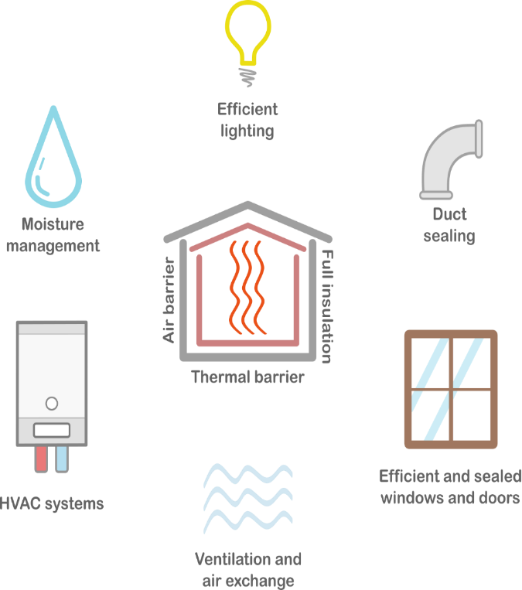
Energy codes cover components of the building itself, such as wall insulation, windows, and air and duct leakage; regulating these elements determines the thermal envelope of a building, thereby controlling moisture, air exchange, and thermal properties.
Systems and conditions regulated by energy codes
Energy codes are only effective when they are adopted and enforced. Savings are only attainable with consistent and widespread adoption, enforcement, and compliance with updated codes.
It takes a village. Several entities play a role in achieving high levels of compliance—not just building officials. Professions involved include architects, designers, contractors and construction professionals, real estate professionals, home inspectors, carpenters, brick and stone masons, concrete finishers, roofers, electricians, engineers, insulation workers, and energy modelers.

Benefits of adopting and enforcing energy codes
Energy codes have many concrete benefits. Consumers and homebuyers can enjoy clean indoor air, lower utility bills, and sustainable homes. Businesses can reduce overhead spending, expand investment opportunities, and gain energy independence.
ECONOMIC ENHANCEMENT: Buildings that comply with updated energy codes are more cost-effective to operate, yielding compounding savings over time for consumers.
Job Creation: Enforcing energy codes creates opportunities for energy, building technology, and construction-related industries.
RESILENCE: Energy codes guard against preventable environmental conditions related to moisture, air quality, fire, and extreme weather events

Enforcing West Virginia’s currently adopted residential energy code can net nearly $11 million in cost savings, which is the same as:
- funding 272 students to attend a four-year college,
- building 83 miles of new bike lanes, or
- powering 14,226 homes for one year.

Energy efficiency in West Virginia buildings
West Virginia has the highest residential electricity consumption per household east of the Mississippi River and the highest total energy consumption per capita in the Appalachian region
Built environment per capita energy consumption (million Btu)
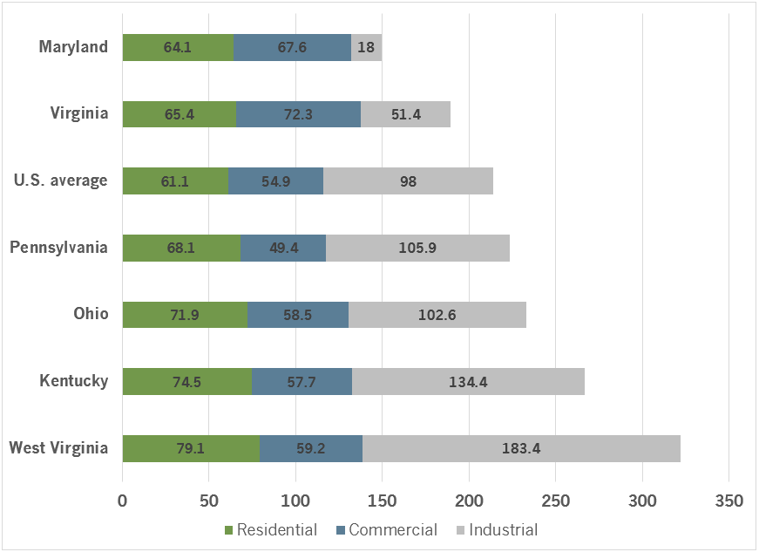

West Virginia is the 48th-least energy efficiency–friendly state in the nation. West Virginia also trails behind each bordering state in both its overall energy efficiency rank and its energy code score.
National energy efficiency ranking and energy code scores
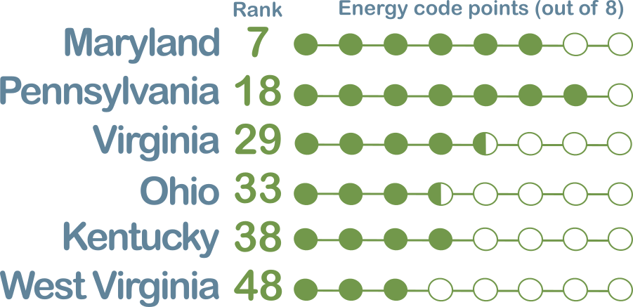
Roadmap for cities and counties
Engage stakeholders
- Form a diverse working group of affected individuals
- Establish objective and realistic goals
Adopt residential and commercial energy codes
3
1
- From the working group, decide energy efficiency goals to pursue
- Adopt the energy code through an ordinance
Enforce the adopted energy codes
2
- Train code officials in energy-related building science
- Code officials ensure compliance tasks are completed
- Create and distribute education and training resources to officials, industry, and consumers

For more information, contact:
West Virginia Office of Energy
State Capitol Complex Building 3, Suite 600
Charleston, WV 25305-0311

(304) 558-2234
www.energywv.org

